Project Documentation: AI Mobile Recommendation Chatbot
Dataset
Dataset Name: Mobile Phone Dataset
Source: C:\Users\Ayesha siddiqa\OneDrive\Desktop\Chatbot_mobile\phone_dataset.csv
About the Dataset
- Number of Rows: 201 Smartphones
- Number of Columns: 33 Features
The dataset contains specifications and AI-generated scores for various smartphones from different brands such as Apple, Samsung, Google, OnePlus, Xiaomi, Vivo, Oppo, Motorola, Nokia, and others.The dataset includes both hardware specifications and performance-related scores, making it suitable for building an intelligent recommendation system.
Important Features in the Dataset
Some of the major attributes available in the dataset are:
- Phone Name
- Company (Brand)
- Price
- Price Category
- Processor
- Processor Score
- RAM (GB)
- Storage (GB)
- Battery Capacity (mAh)
- Charging Speed (Watts)
- Display Size
- Display Type
- Refresh Rate
- Rear Camera
- Front Camera
- Operating System
- Gaming Score
- Camera Score
- Performance Score
- Battery Score
- Value for Money Score
- Recommendation Score
- User Rating
- Best For
These features allow the chatbot to recommend smartphones based on user preferences and compare multiple devices accurately.
Understanding the Problem
What is a Mobile Recommendation System?
With hundreds of smartphones available in the market, selecting the right device has become increasingly difficult. Users often have different requirements such as budget, camera quality, gaming performance, battery life, or preferred brand.
Searching through numerous websites and comparing specifications manually is both time-consuming and confusing.
The objective of this project is to build an AI-powered Mobile Recommendation Chatbot that understands natural language queries and provides personalized smartphone recommendations instantly.
The chatbot allows users to:
- Recommend smartphones based on budget
- Recommend gaming, camera, or battery phones
- View complete phone specifications
- Compare two smartphones
- Find similar smartphones
- Continue conversations using context memory (e.g., "compare both")
Project Objectives
The main objectives of this project are:
- Develop an AI-powered chatbot using Python.
- Understand user queries using Natural Language Processing (NLP).
- Recommend smartphones based on user preferences.
- Display detailed phone specifications.
- Compare two smartphones side-by-side.
- Suggest similar smartphones using similarity algorithms.
- Build an interactive web interface using Streamlit.

Step 1: Import Required Libraries
The first step is to import all the required Python libraries. Each library performs a specific task during data preprocessing, Natural Language Processing (NLP), recommendation generation, and web application development.
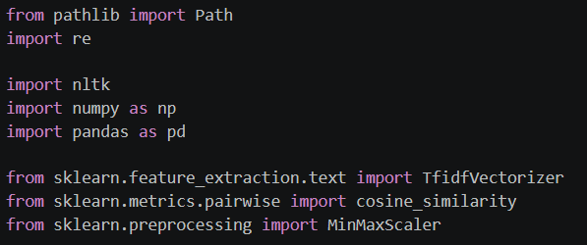

- Purpose of Each Library
Library | Purpose
Pandas | Used for loading, cleaning, filtering, and manipulating the smartphone dataset.
NumPy | Used for numerical computations and matrix operations.
Regular Expressions (re) | Used for cleaning text and extracting information such as budget from user queries.
Pathlib | Used for creating platform-independent file paths to access the dataset.
NLTK | Used for Natural Language Processing tasks such as tokenization.
TF-IDF Vectorizer | Converts textual smartphone descriptions into numerical vectors for similarity calculation.
Cosine Similarity | Measures similarity between user queries and smartphone descriptions. It is also used for recommending similar smartphones.
MinMaxScaler | Scales numerical features between 0 and 1 before calculating similarity scores.

Step 2: NLTK Setup
Natural Language Toolkit (NLTK) is used to perform text preprocessing. Before using NLTK, the required tokenizer package must be downloaded.
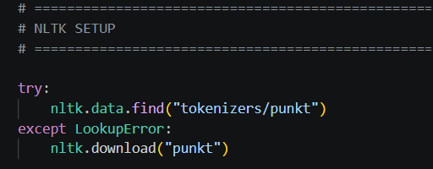
Explanation
- The chatbot first checks whether the punkt tokenizer is already installed.
- If it is not available, NLTK automatically downloads it.
- This prevents repeated downloads every time the program runs.

Observation
This step ensures that all Natural Language Processing operations execute without errors during chatbot execution.
Step 3: Loading the Dataset
The smartphone dataset is loaded into a Pandas DataFrame for further preprocessing and analysis.
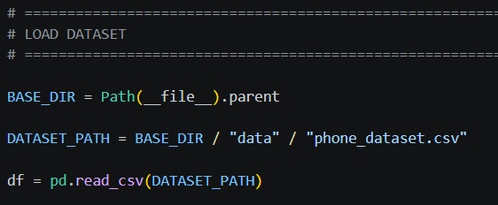
Explanation
- BASE_DIR identifies the current project directory.
- DATASET_PATH stores the location of the smartphone dataset.
- pd.read_csv() loads the dataset into the DataFrame named df.
The DataFrame acts as the primary data structure used throughout the chatbot.
Observation
Once loaded successfully, the chatbot can access all smartphone specifications, ratings, AI scores, and pricing information for recommendation and comparison.

Step 4: Understanding the Dataset
Before applying any machine learning or recommendation techniques, it is important to understand the structure of the dataset.
df.head()
df.info()
df.shape
df.describe()

Explanation
- df.head() displays the first five records of the dataset.
- df.info() provides information about column names, data types, and missing values.
- df.shape returns the number of rows and columns.
- df.describe() generates statistical information for numerical columns.

Observations
- The dataset contains 201 smartphone records.
- The dataset consists of 33 attributes describing smartphone specifications and AI-generated scores.
- Numerical columns such as Price, RAM, Storage, Battery Capacity, and AI Scores are already available in numeric format.
- Textual columns such as Phone Name, Company, Processor, and Display Type are used later for Natural Language Processing.
- Step 5: Text Cleaning and Preprocessing
- Before performing any Natural Language Processing (NLP) tasks, the textual data must be cleaned and standardized. Raw text often contains uppercase letters, punctuation marks, and special characters that do not contribute to understanding user intent.
- The text cleaning process ensures that both the smartphone descriptions and user queries follow a consistent format, resulting in better recommendation accuracy.

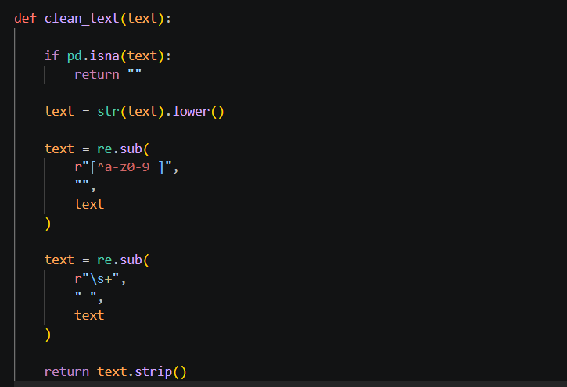

Explanation
The clean_text() function performs the following preprocessing steps:
- Checks for Missing Values
  - If the input text is empty or contains a null value (NaN), an empty string is returned.
- Converts Text to Lowercase
  - All uppercase letters are converted to lowercase.
- Removes Special Characters
  - All punctuation marks and special symbols are removed using Regular Expressions.
  - Example:
- Returns Clean Text
  - The processed text is returned for further NLP processing.
Why is Text Cleaning Important?
Natural Language Processing algorithms treat words with different cases or punctuation as different words.
Observation
The text cleaning process standardizes all textual information, making it easier for the chatbot to understand user queries and perform accurate recommendations.

Step 6: Creating Search Descriptions
To enable intelligent smartphone recommendations, multiple important attributes of each smartphone are combined into a single textual description.
Instead of searching through individual columns separately, the chatbot searches this combined description using Natural Language Processing techniques.
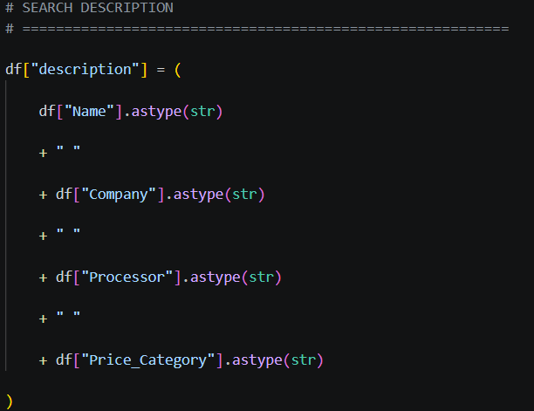

Explanation
A new column named description is created by combining important smartphone attributes, including:
- Phone Name
- Company (Brand)
- Processor
- Price Category
Why Combine Multiple Columns?
Instead of searching each column individually, the chatbot creates one searchable text field.
This allows Natural Language Processing algorithms to understand user queries such as:
- Recommend Samsung phones
- Gaming phones with Snapdragon
- Premium smartphones
- Google Pixel phones
more efficiently.
Observation
The newly created description column acts as the knowledge base for the recommendation engine and significantly improves the chatbot's ability to match user queries with relevant smartphones.
Step 7: TF-IDF Vectorization
Natural Language Processing models cannot understand plain text directly. Therefore, the textual descriptions must be converted into numerical vectors.
The chatbot uses Term Frequency–Inverse Document Frequency (TF-IDF) to transform smartphone descriptions into machine-readable numerical representations.
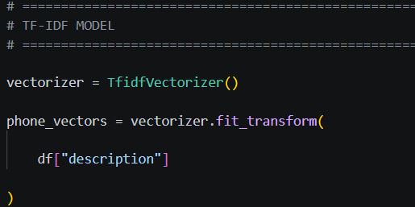

Explanation
The TfidfVectorizer() converts every smartphone description into a vector based on the importance of each word.
The process consists of two steps:
- Fit
  - Learns the vocabulary from all smartphone descriptions.
- Transform
  - Converts every smartphone description into a numerical TF-IDF vector.
These vectors are later used to compare the similarity between a user's query and every smartphone in the dataset.
Why TF-IDF?
TF-IDF assigns higher importance to words that are unique and informative while reducing the importance of commonly occurring words.
Observation
TF-IDF converts textual smartphone descriptions into numerical vectors, enabling the chatbot to perform intelligent text-based search and recommendation using similarity calculations.

Step 8: Processing User Queries
After preparing the smartphone dataset, the chatbot must also preprocess the user's input before performing any recommendation or search.
The query is cleaned using the same preprocessing function applied to the dataset, ensuring consistency between the user's input and the stored smartphone descriptions.
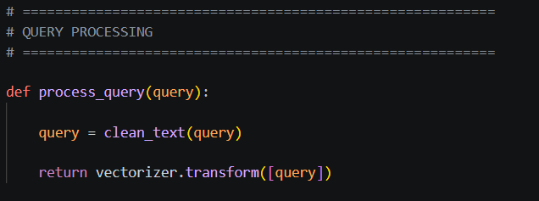
Explanation
The process_query() function performs two operations:
- Text Cleaning
  - Converts the user's input into lowercase.
  - Removes punctuation and unnecessary special characters.
  - Standardizes the query format.
- TF-IDF Transformation
  - Converts the cleaned query into a TF-IDF vector using the trained vectorizer.
  - This vector is later compared with all smartphone vectors using Cosine Similarity.
Observation

By converting the user's query into a numerical vector, the chatbot can accurately compare it with every smartphone description stored in the dataset.

Step 9: Creating User Preference Dictionaries
To understand user preferences more effectively, the chatbot uses predefined dictionaries that map various keywords to brands and smartphone features.
These dictionaries help identify the user's intended brand or preferred feature even when different words are used.
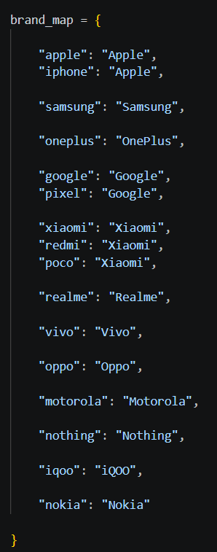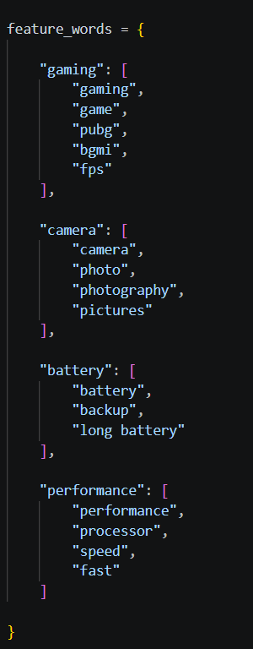
Explanation
The chatbot maintains two dictionaries

Brand Dictionary
Maps different user keywords to a standard company name.
For example:
User Input | Stored Brand
iphone | Apple
apple | Apple
pixel | Google
redmi | Xiaomi
poco | Xiaomi
This allows different user expressions to refer to the same brand.

Feature Dictionary
Similarly, feature-related words are grouped together.
For example:
User Keyword | Detected Feature
gaming | Gaming
PUBG | Gaming
FPS | Gaming
camera | Camera
photography | Camera
battery | Battery
fast | Performance
This enables the chatbot to understand the user's requirement even if different terminology is used.
Observation
The dictionaries improve the chatbot's Natural Language Understanding by allowing multiple words to represent the same brand or smartphone feature.
Step 10: Budget Extraction
Budget is one of the most important factors when recommending smartphones.
The chatbot automatically extracts the user's budget from natural language queries using Regular Expressions (Regex).

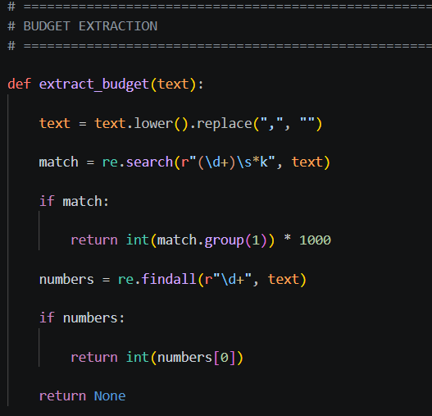
Explanation
The chatbot supports multiple budget formats.

Step 11: Brand Extraction
After determining the budget, the chatbot identifies whether the user has requested a specific smartphone brand.
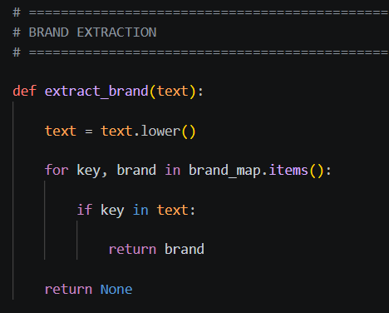
Explanation
The function compares the user's query with the predefined brand dictionary.
User Input | Extracted Brand
Recommend Samsung phones | Samsung
Best iPhone | Apple
Google Pixel phones | Google
Redmi under ₹20,000 | Xiaomi

Observation
This approach allows the chatbot to recognize brand preferences regardless of the exact wording used by the user.

Step 12: Feature Extraction
In addition to brand and budget, users often specify the purpose of the smartphone, such as gaming, photography, battery life, or performance.
The chatbot identifies these preferences using keyword matching.
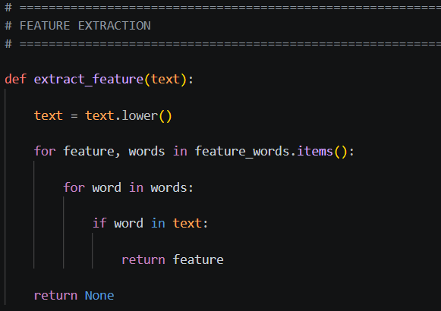
Explanation
The function searches for predefined keywords within the user's query.
User Query | Detected Feature
Recommend a gaming phone | Gaming
Best camera phone | Camera
Long battery backup | Battery
Fast performance | Performance

Observation
Feature extraction enables the chatbot to recommend smartphones that are specifically optimized for the user's intended use.
Step 13: Intent Detection
Explain that the chatbot identifies the user's intention before generating a response.
Supported intents include:
- Greeting
- Help
- Recommendation
- Phone Specification
- Phone Comparison
- Similar Phones
The intent is detected using keyword matching. Once identified, the request is routed to the corresponding module.
Observation:
Intent detection enables the chatbot to understand different types of user requests and respond appropriately.
Step 14: Phone Name Extraction
The chatbot extracts smartphone names from user queries using an alias dictionary.
Examples:
- "iPhone 15" → Apple iPhone 15
- "Galaxy S24" → Samsung Galaxy S24
- "Pixel 9 Pro" → Google Pixel 9 Pro
This allows users to type partial or shortened phone names instead of full model names.
Observation:
Phone alias mapping improves usability by recognizing multiple variations of the same smartphone.

Step 15: Recommendation Engine
The recommendation engine filters smartphones based on:
- Budget
- Preferred Brand
- Desired Feature (Gaming, Camera, Battery, Performance)
After filtering, TF-IDF similarity is calculated between the user query and smartphone descriptions.
A final recommendation score is computed using:
- 50% NLP Similarity
- 30% Feature Score
- 20% User Rating
The smartphones are then ranked and the top recommendations are displayed.
Observation:
Combining NLP similarity with feature scores provides more personalized recommendations than using keyword matching alone.
Step 16: Phone Specification Module
When a user requests information about a smartphone, the chatbot retrieves its complete specifications from the dataset.
Displayed information includes:
- Brand
- Price
- Processor
- RAM
- Storage
- Battery
- Charging Speed
- Display
- Cameras
- AI Scores
- User Rating
Observation:
This module provides complete smartphone information without requiring users to browse multiple websites.
Step 17: Similar Phone Recommendation
To recommend alternatives, the chatbot combines:
- TF-IDF similarity of smartphone descriptions
- Numerical similarity using specifications
Cosine Similarity is used to calculate how closely two smartphones resemble each other.
The top five most similar smartphones are displayed.
Observation:
This feature helps users discover alternative smartphones with similar specifications and performance.
Step 18: Conversation Memory
The chatbot stores important information from previous interactions, including:
- Preferred Brand
- Budget
- Preferred Feature
- Last Phone Viewed
- Last Two Phones Compared
This enables contextual conversations.
Example:
User: Tell me about iPhone 15
User: Tell me about Samsung Galaxy S24
User: Compare both
The chatbot automatically understands that "both" refers to the previously discussed smartphones.
Observation:
Conversation memory creates a more natural and user-friendly chat experience.
Step 19: Streamlit Web Application
The chatbot is deployed using Streamlit.
The interface includes:
- Chat interface
- Sidebar
- Example questions
- Chat history
- Clear chat button
- Comparison tables
- Markdown formatted responses
Observation:
Streamlit provides an interactive and user-friendly interface without requiring web development frameworks.
Step 20: Conclusion
The AI Mobile Recommendation Chatbot successfully combines Natural Language Processing, recommendation algorithms, and conversational memory to assist users in selecting smartphones based on their preferences.
The system provides:
- Personalized smartphone recommendations
- Detailed specifications
- Smartphone comparisons
- Similar phone suggestions
- Context-aware conversations
The project demonstrates the practical application of NLP, TF-IDF vectorization, Cosine Similarity, and Python-based web development to solve a real-world decision-making problem.

